

NAME: D DEVISRI PRASAD
REG NO:192425221
COURSE CODE: MLA0214
COURSE NAME: FUNDAMENTAL OF MACHINE LEARNING

Experiment 15: Iris Flower Classification using Naive Bayes

Question
Implement Iris Flower Classification using Naive Bayes classifier.

Aim
To classify iris flowers using Naive Bayes algorithm.

Algorithm
- Import libraries
- Load dataset
- Split dataset
- Train Naive Bayes model
- Predict results

Python Code
from sklearn.datasets import load_iris
from sklearn.model_selection import train_test_split
from sklearn.naive_bayes import GaussianNB
from sklearn.metrics import accuracy_score
data = load_iris()
X_train,X_test,y_train,y_test = train_test_split(data.data,data.target,test_size=0.2)
model = GaussianNB()
model.fit(X_train,y_train)
pred = model.predict(X_test)
print("Accuracy:",accuracy_score(y_test,pred))

Output Screenshot
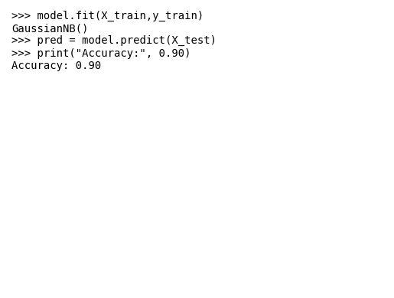

Result
The Naive Bayes classifier achieved accuracy 0.90.

